Materials List:

1. ECG board (ADS 1292r)
2. PPG sensor and board (Max 30102)
3. Max 30102 fabric fixture
4. GSR board (Seeed studio Grove - GSR)
5. GSR electrodes
6. Three lead electrodes
7. GSR 4 pin out cable connection
8. 1 bread board
9. 1 arduino uno r3
10. 16 male to female wires
11. 5 male to male wires
12. USB Type B to A cable (for Arduino Uno R3)

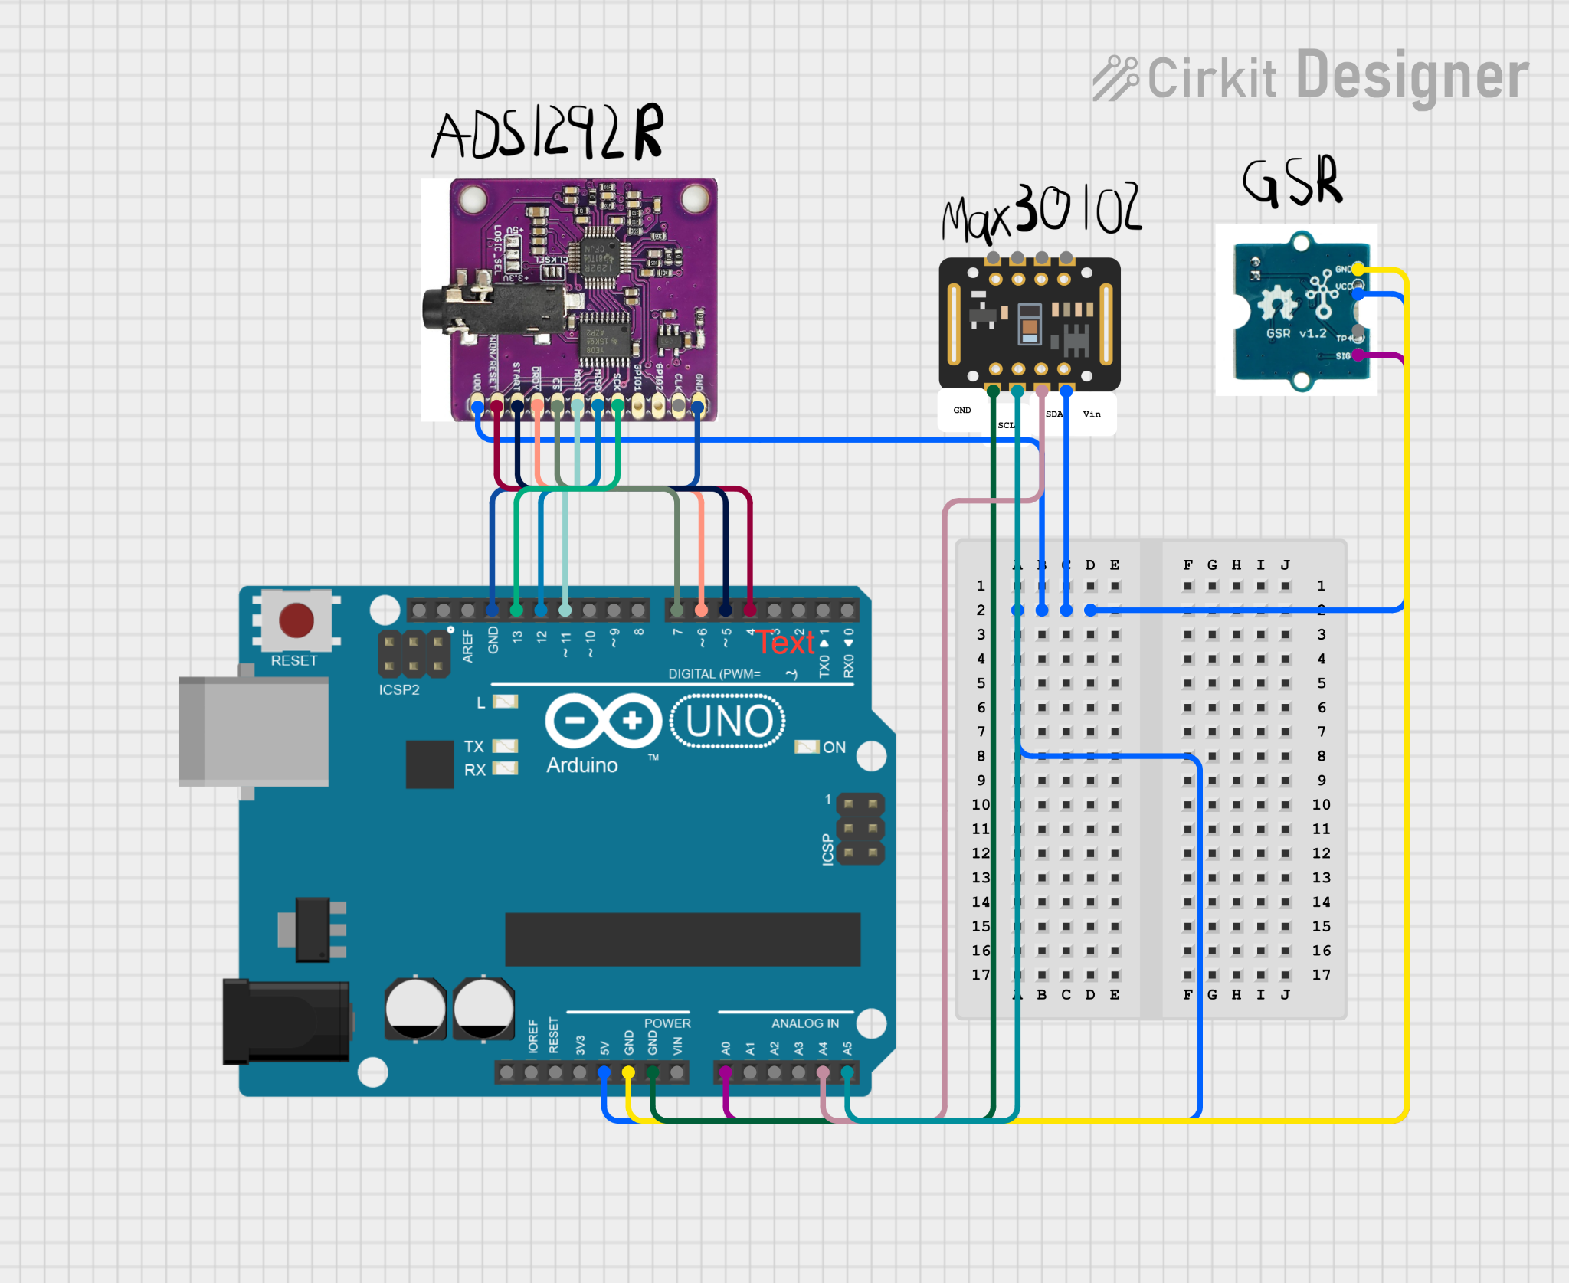

**Instructions for hardware setup:**

1. Connect MAX 30102 to arduino.
   1. Attach Max30102 to the fixture before connecting the board to the arduino.
      1. 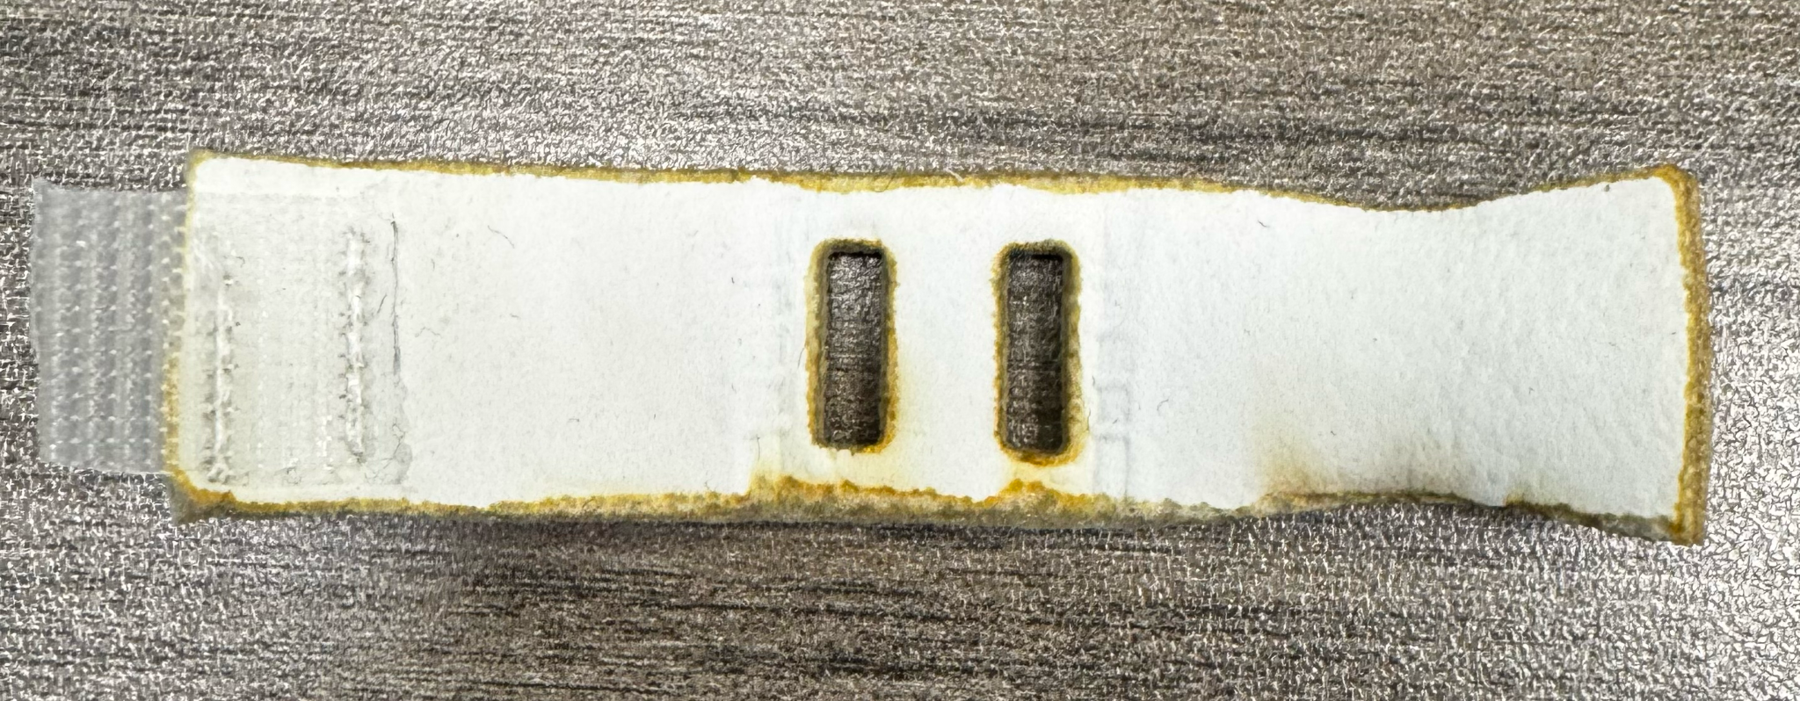
      2. 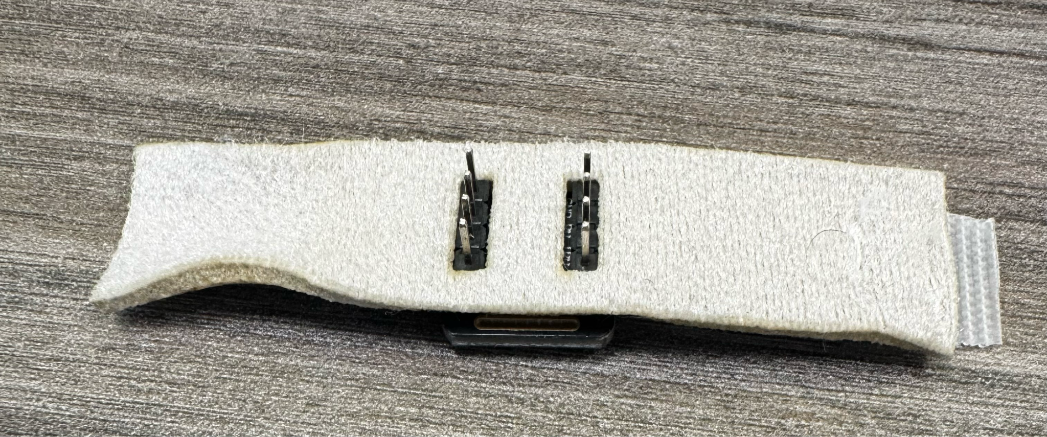
   2. Using 1 male to female wire connect Vin pin to slot 2C on the bread board.
   3. Using 1 male to female wire connect SDA pin to slot A4 on the arduino.
   4. Using 1 male to female wire connect SCL pin to slot A5 on the arduino.
   5. Using 1 male to female wire connect GND pin to any GND slot on the arduino.
   6. For more freedom of movement with Max 30102 you can wire all pins to the breadboard, then connect all wires to their respective slots.
      1. If you wish to do so, use the 4 male to male wires for this step.
2. Connect ADS 1292R to arduino.
   1. Using 1 male to female wire connect any 5V pin (but only connect one of them) to slot 2B on the breadboard.
   2. Using 1 male to female wire connect any GND (but only connect one of them) to any empty GND slot on the arduino.
   3. Using 1 male to female wire connect MISO to slot D12 on the arduino
   4. Using 1 male to female wire connect DRDY to slot D6 on the arduino
   5. Using 1 male to female wire connect MOSI to slot D11 on the arduino
   6. Using 1 male to female wire connect SCK to slot D13 on the arduino
   7. Using 1 male to female wire connect CSO to slot D7 on the arduino
   8. Using 1 male to female wire connect PWDN to slot D4 on the arduino
   9. Using 1 male to female wire connect START to slot D5
3. Once all wires are connected connect the 3 lead ecg wire to 3.5 mm jack mount.
   1. 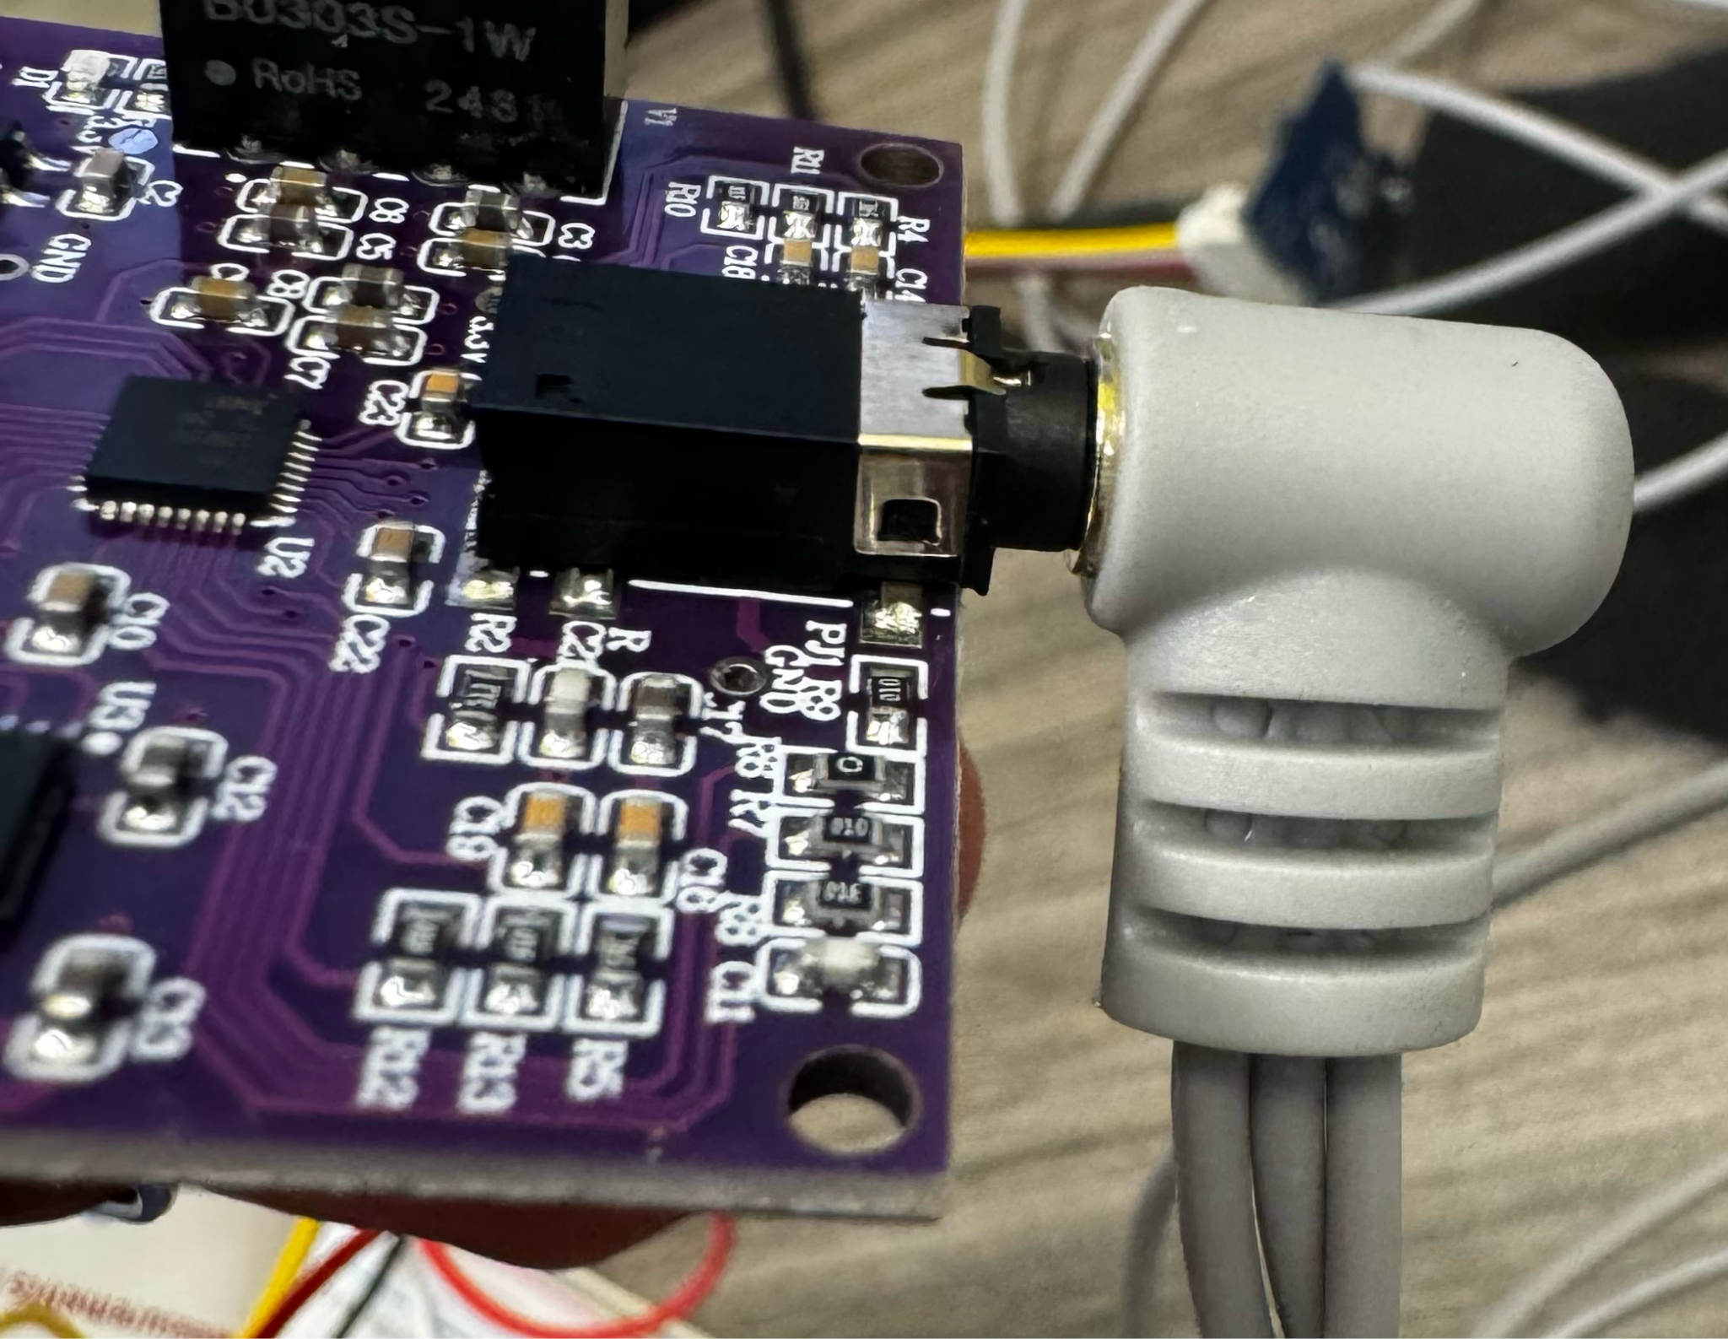
4. Connect Seeed Studio Grove - GSR to arduino
   1. Connect the 4 pin connection from the kit to designated location on the GSR board.
      1. 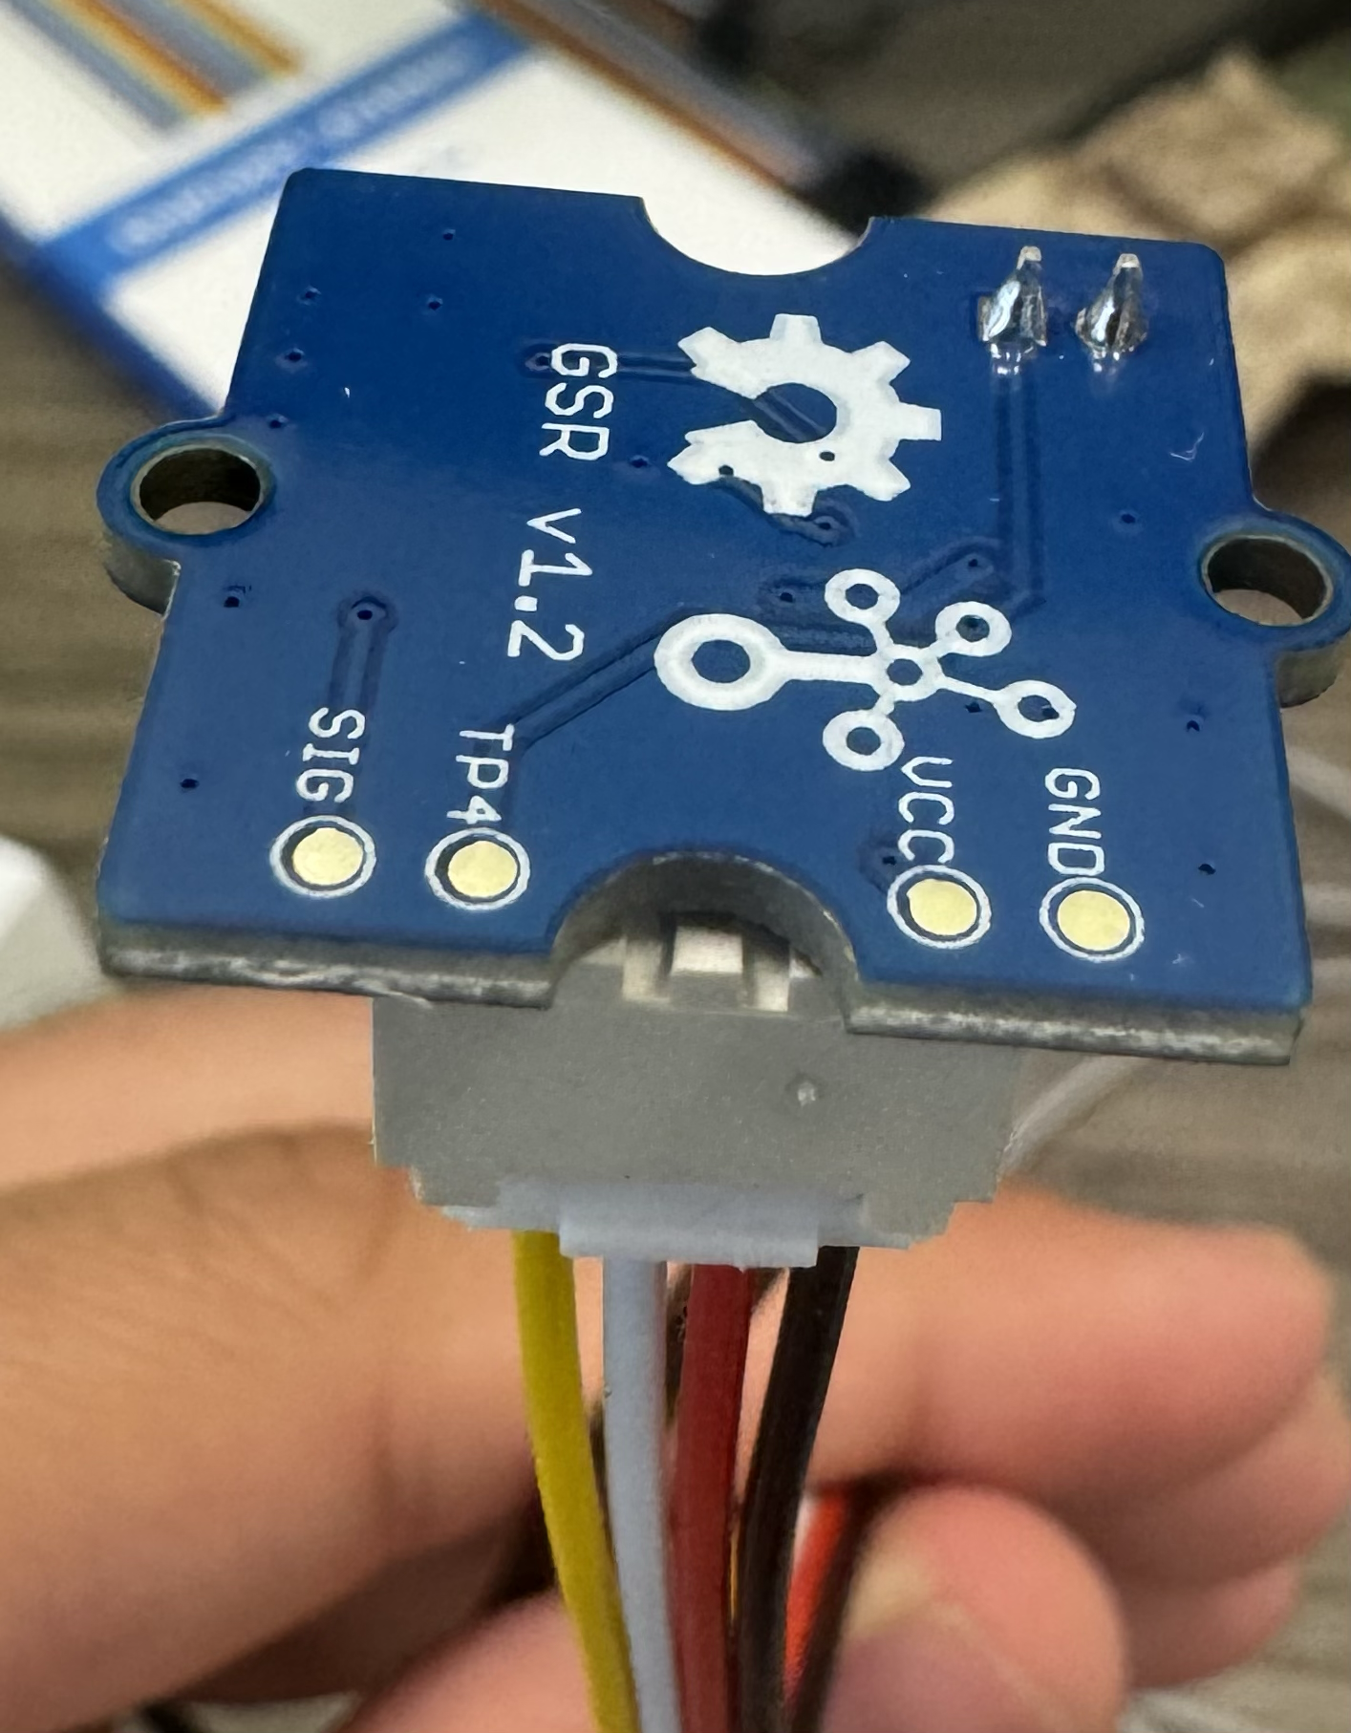
   2. Then connect 4 male to female wires to the other side of the 4 pin connection.
      1. The black wire corresponds to GND
      2. The red wire corresponds to Vcc
      3. The white wire corresponds to TP4
      4. The yellow wire corresponds to SIG
   3. Then tape the wires together with electrical tape like the image below.
      1. 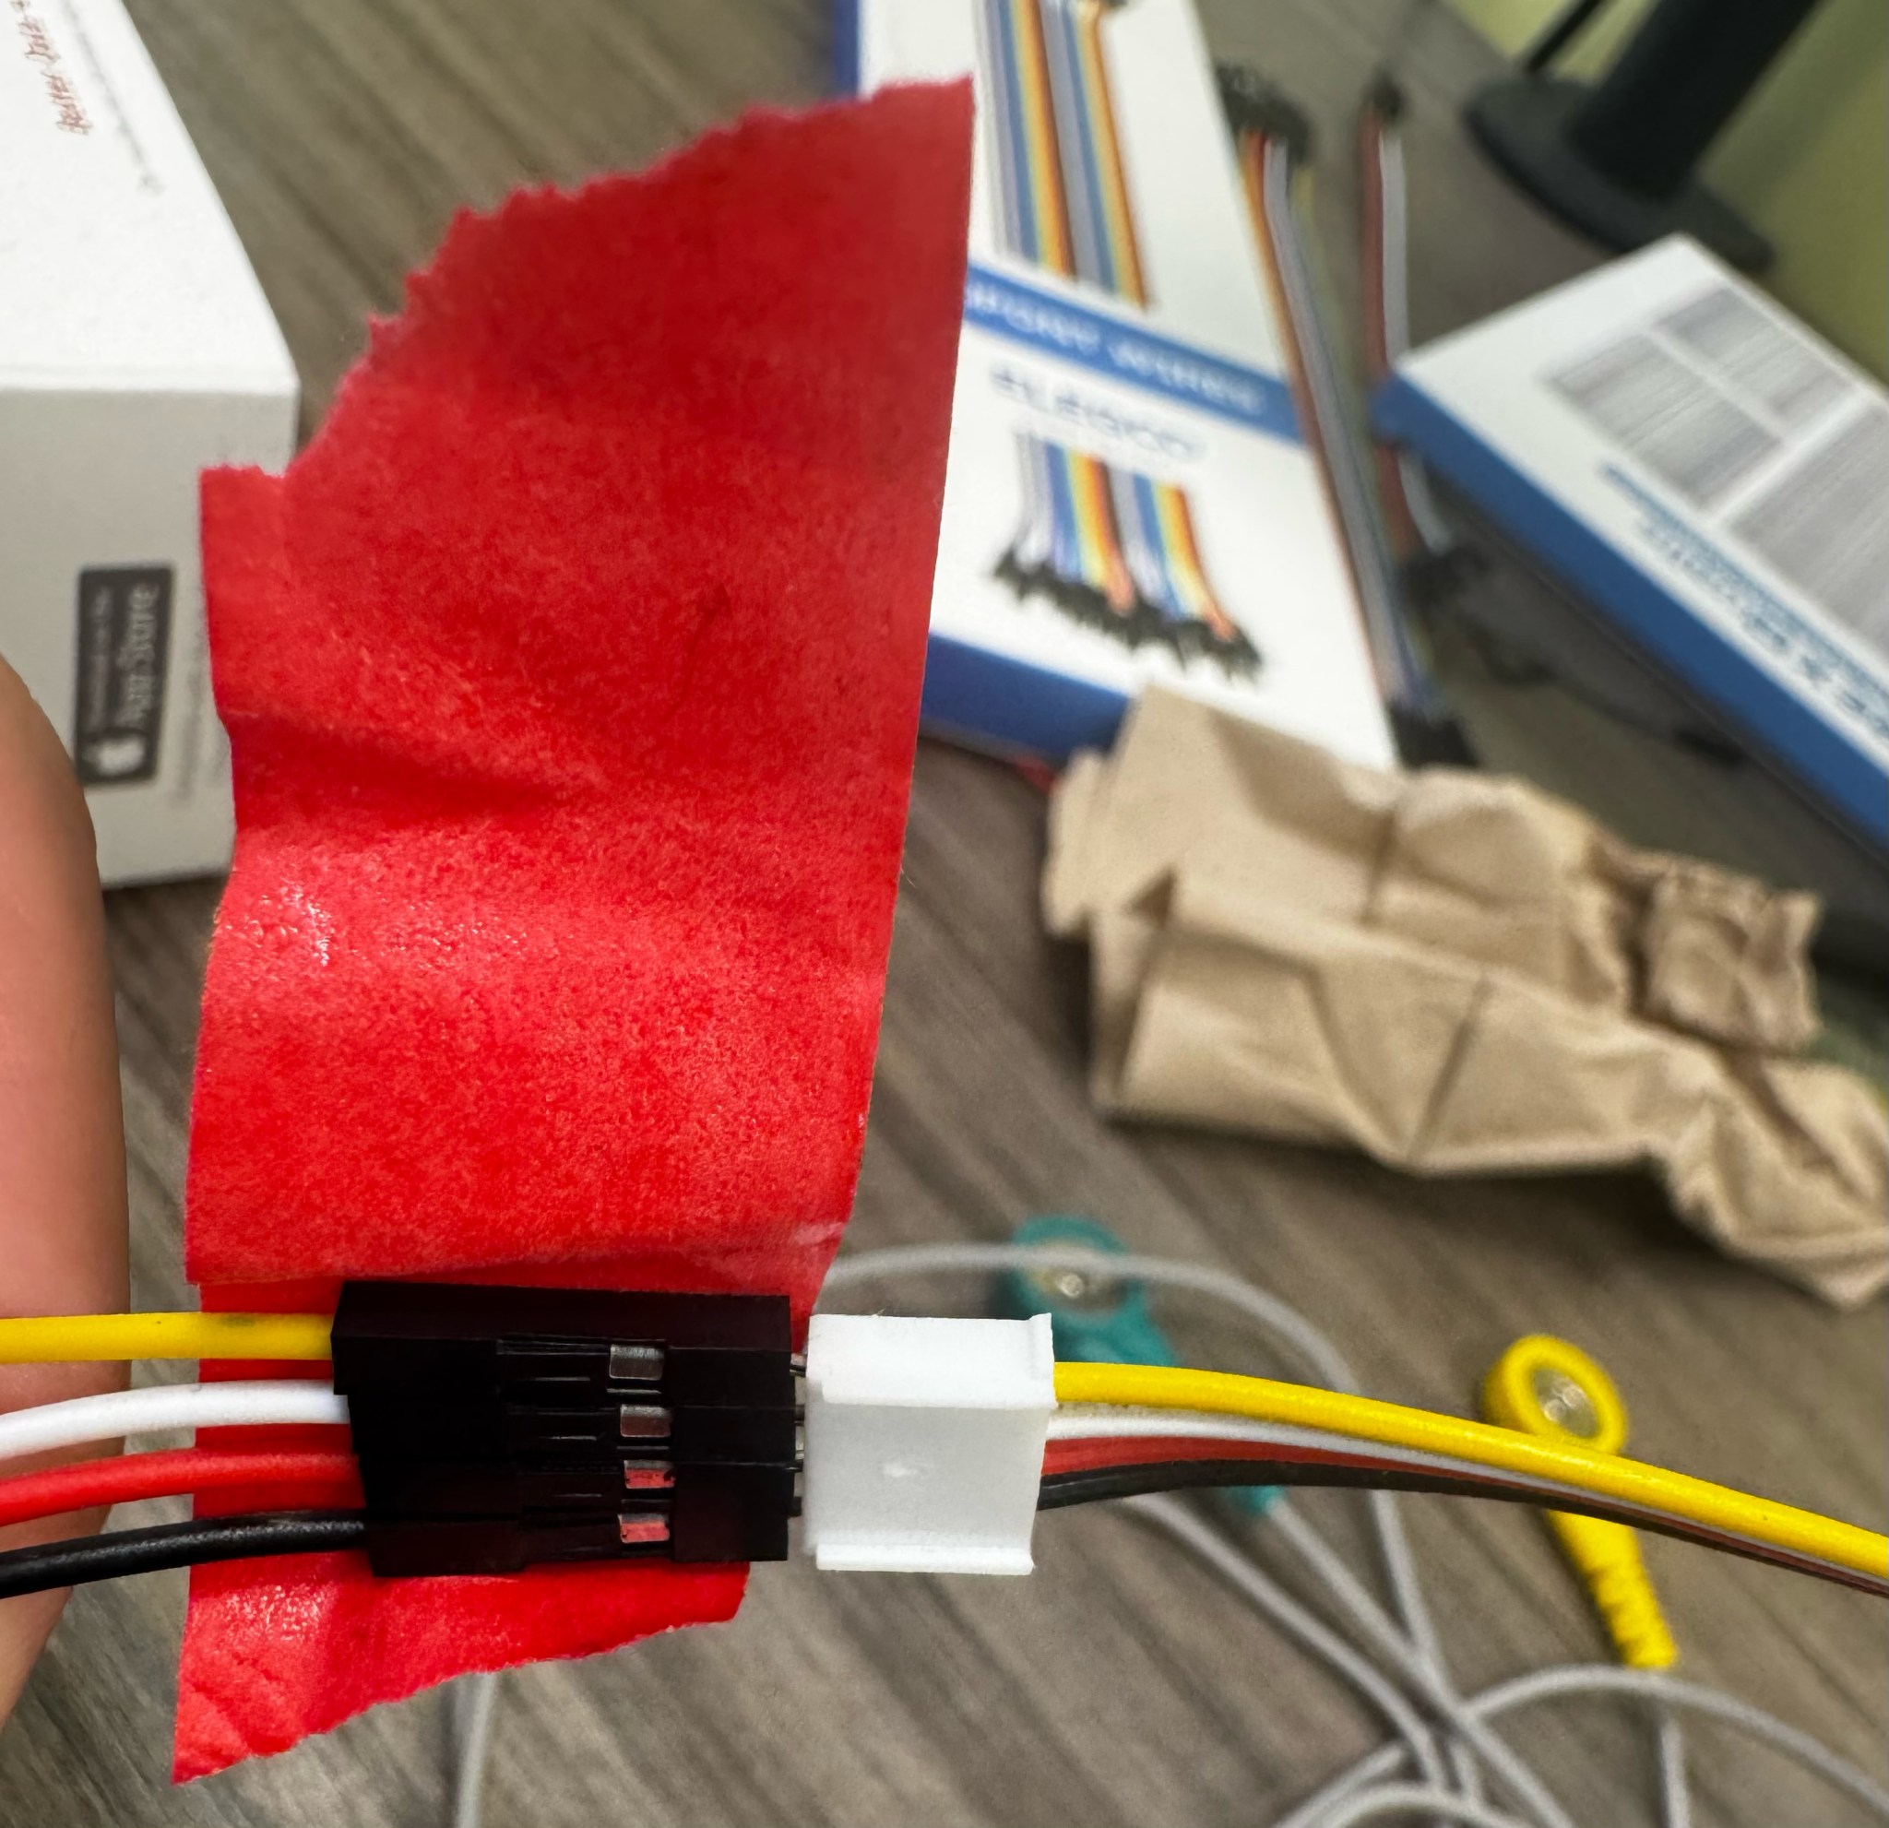
   4. Connect the yellow wire to A0 port on the arduino
   5. Connect the black wire to any empty GND port on the arduino
   6. Connect the red wire to the 2D port on the bread board
   7. You leave the white wire taped or completely disconnected because it serves no purpose for any experiments conducted on the platform.
   8. To connect the GSR electrodes to the GSR board connect the two pin in the following configuration as seen in the image below.
      1. 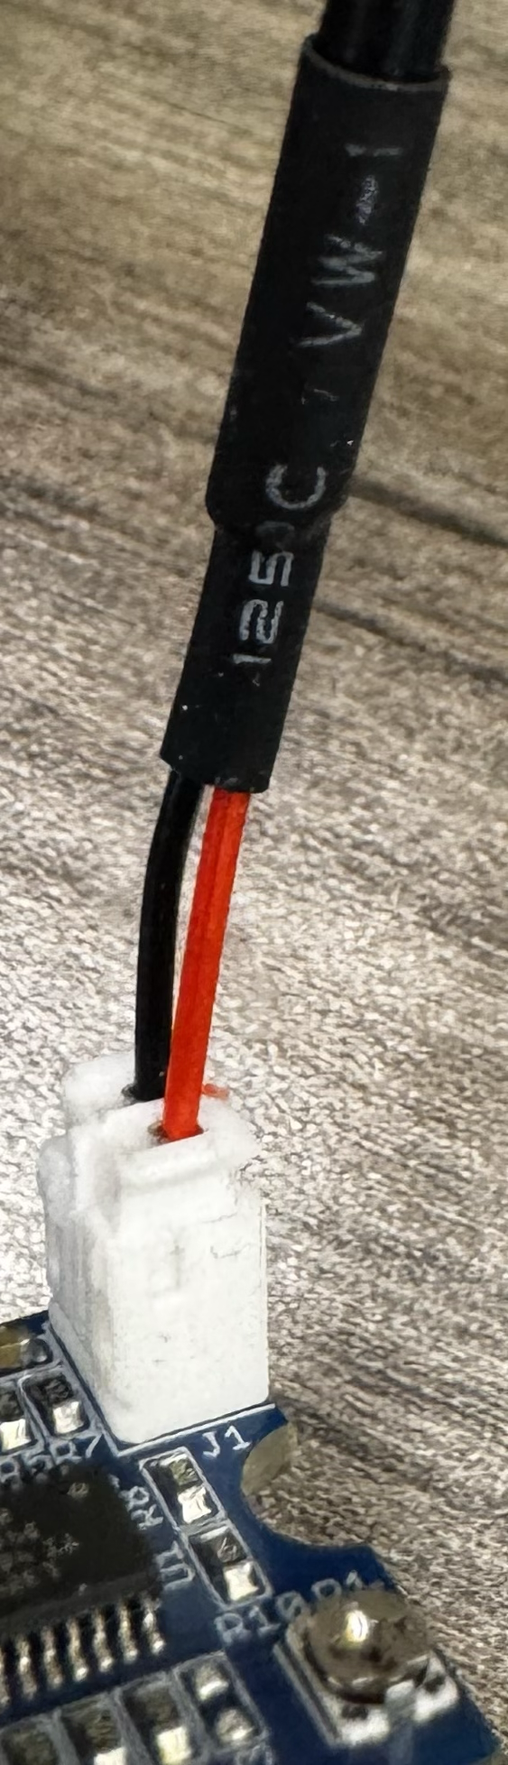
5. To connect all the boards to the power port on the arduino, take a male to male wire and connect it to 2A on the bread board and the 5V port on the arduino.
6. Then to connect the arduino to the computer and power supply, take the USB type A to B wire and connect the type A end to the computer and the type B end to the arduino.

**Instructions to Upload Firmware:**

1. After completing all the steps for hardware setup, open the “Arduino IDE” application.
2. Make sure your arduino is connected to the IDE. Your screen should look similar to the image below.
   1. 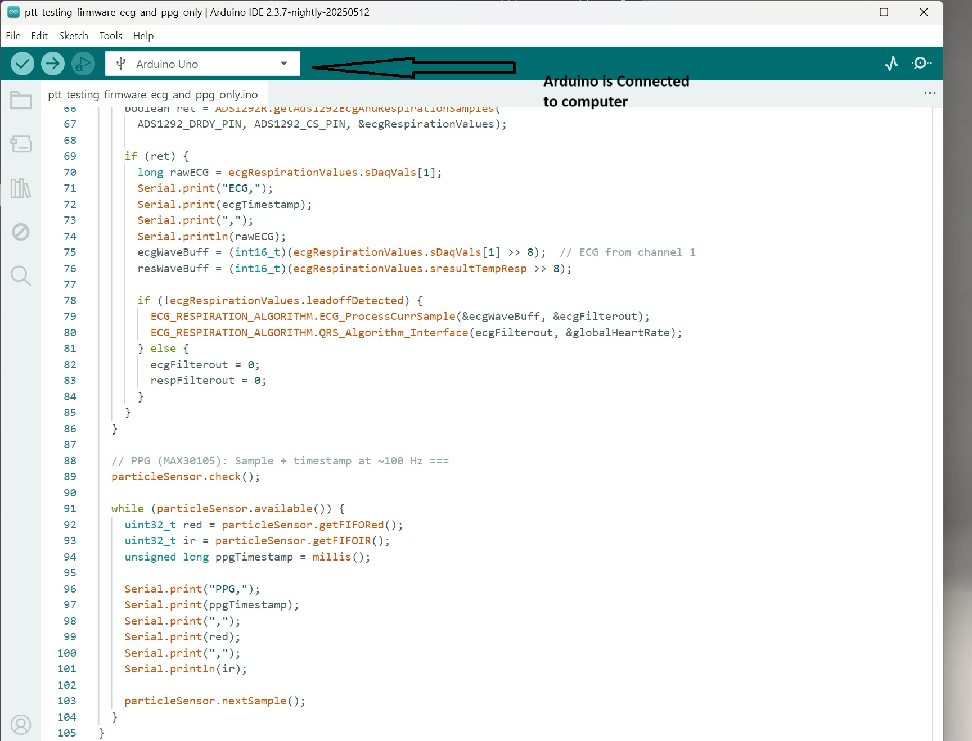
3. Open a firmware file to begin testing.
   1. For example go to file -> open -> “ptt_testing_firmware_ecg_and_ppg_only”
4. Then press Ctrl + R to verify and compile the file.
5. Once verification is complete press Ctrl + U to upload the file to the arduino.
   1. By now all boards that are in use should have some sort of a flashing LED turned on.

**Instructions for Data Collection:**

1. Next you will open the “CoolTerm” application.
2. Once open your screen should look like the following image below.
   1. 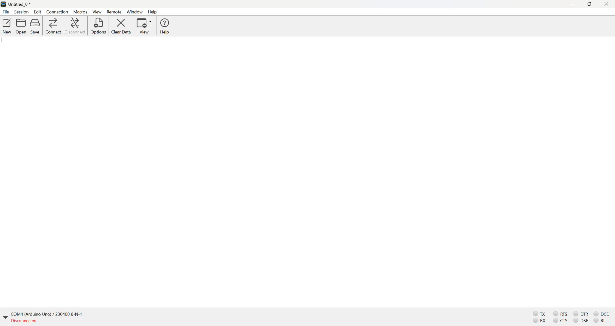
3. To ensure proper connection press the connection button on the top left tab.
4. Then press options.
   1. Your screen should look like the following image below.
   2. 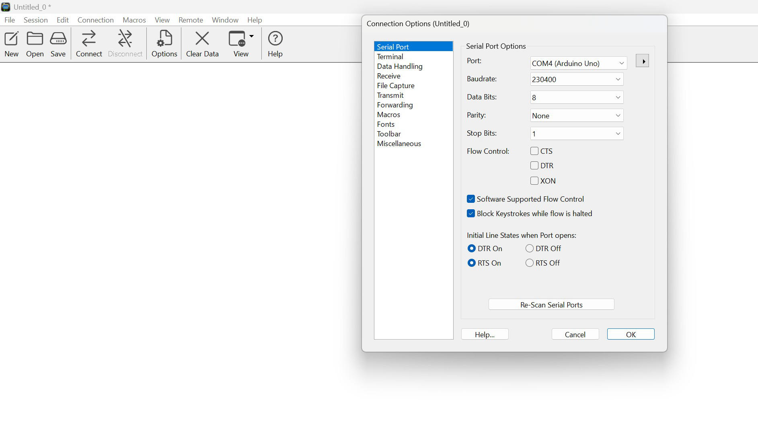
   3. Make sure it says COM4 (or w/e COM your arduino is on) on “port:”
   4. The baud rate should match what it says in the firmware file.
      1. In this case its “230400”
   5. Make sure all other settings match what's on the image.
5. Once all connection settings are satisfied press ok.
6. Then press the “connect” button at the top left of the window.
7. After a couple of seconds you should see a stream of data, as seen in the image below.
   1. 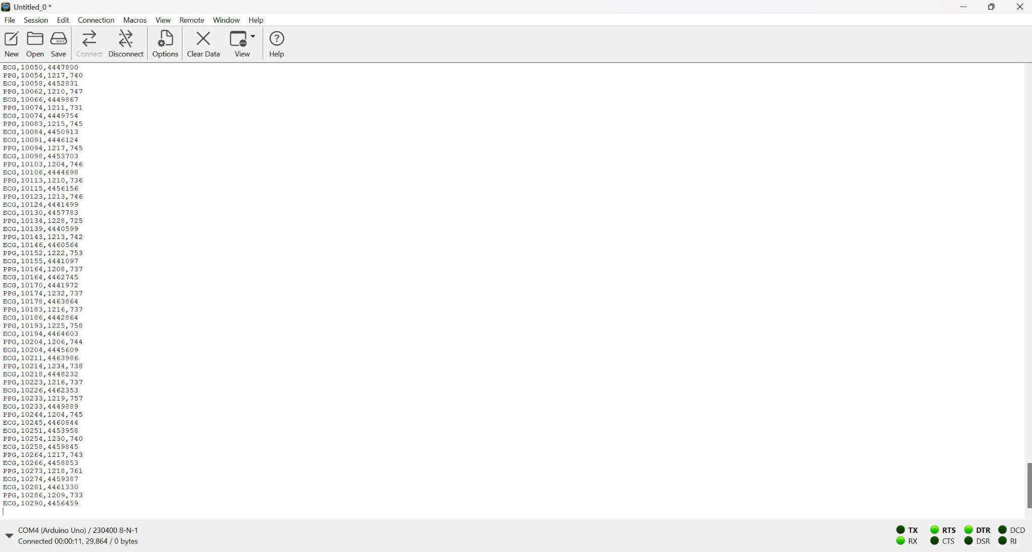
8. Before beginning to record make sure to place ecg patches and leads in the following configuration.
   1. 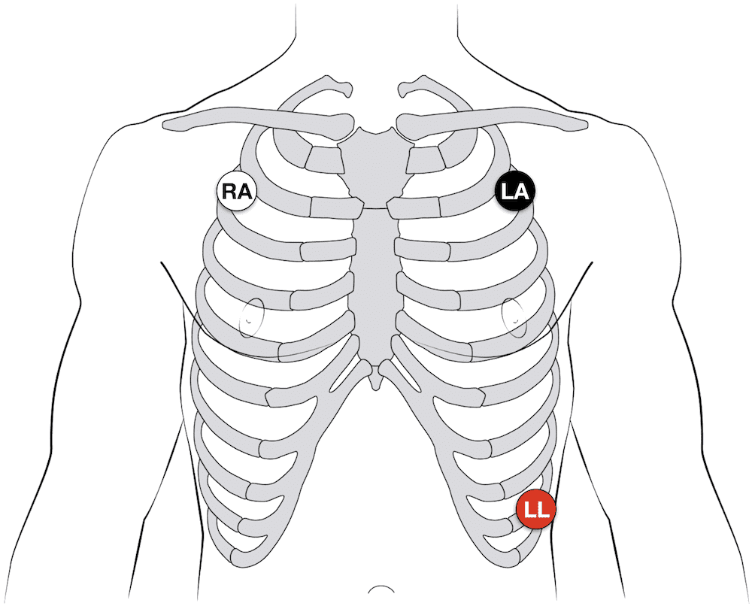
9. Then place the GSR electrodes on the middle and ring finger of the left hand, as well as strapping the Max 30102 sensor to the index finger of your left hand.
   1. The setup should look like the following image below.
   2. 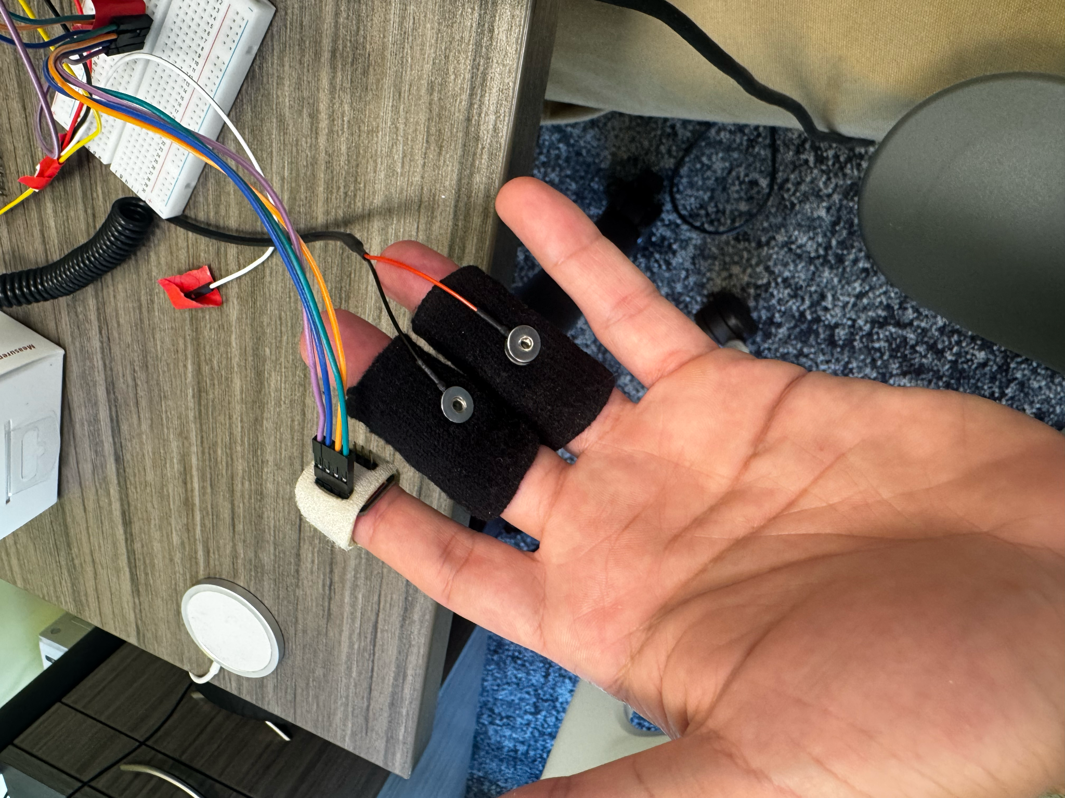
   3. 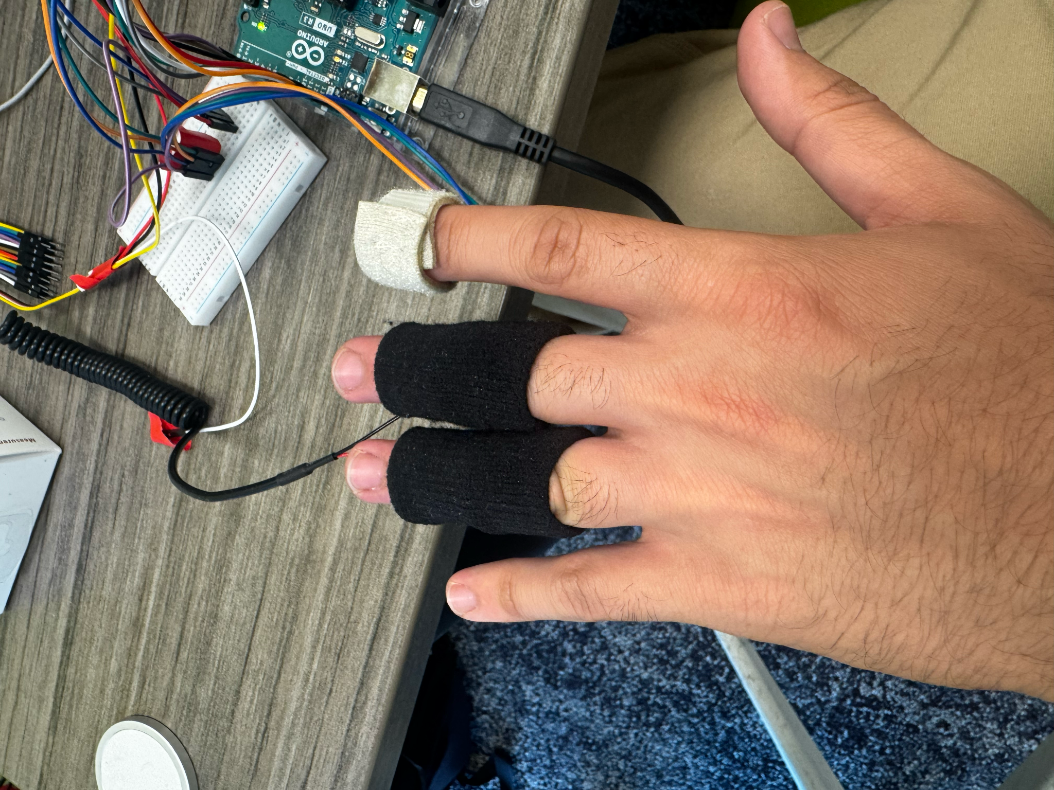
   4. Make sure the gsr electrodes are in contact with the middle pads of your finger (otherwise known as your middle phalanx). Additionally make sure the max 30102 flashing led red light comes in contact with the middle portion of the index finger tip (otherwise known as the distal phalanx).
   5. Fingers should be supported for accurate ppg readings.
      1. Consider placing the palm of your hands over a box to support the fingers.
10. Once all sensors are connected and you are ready to record, press “clear data” at the top left and Ctrl + R.
11. Then you will get a screen prompting you where to save the file location and the file name.
12. Once you verify file location and name, press enter and recording will begin.
13. To end the recording press Ctrl + R again. (nothing will pop up on screen, but data will cease being written to the file)

**Instructions for exporting data file as csv:**

1. Open excel.
2. Then go to “open” and open the text file cool term saved in its designated location.
   1. Your screen should look something like the image below once you have selected the text file.
   2. 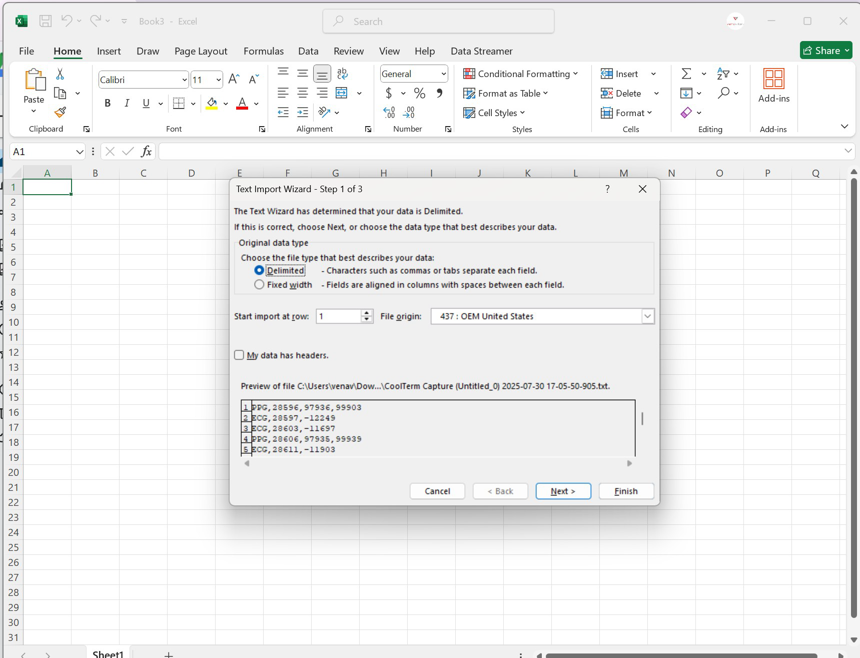
3. Once you have successfully opened the file press “Next >”
4. You will then be prompted on how you would like Excel to separate the text file.
   1. For this step make sure you select “comma” like how it looks on the image below.
   2. 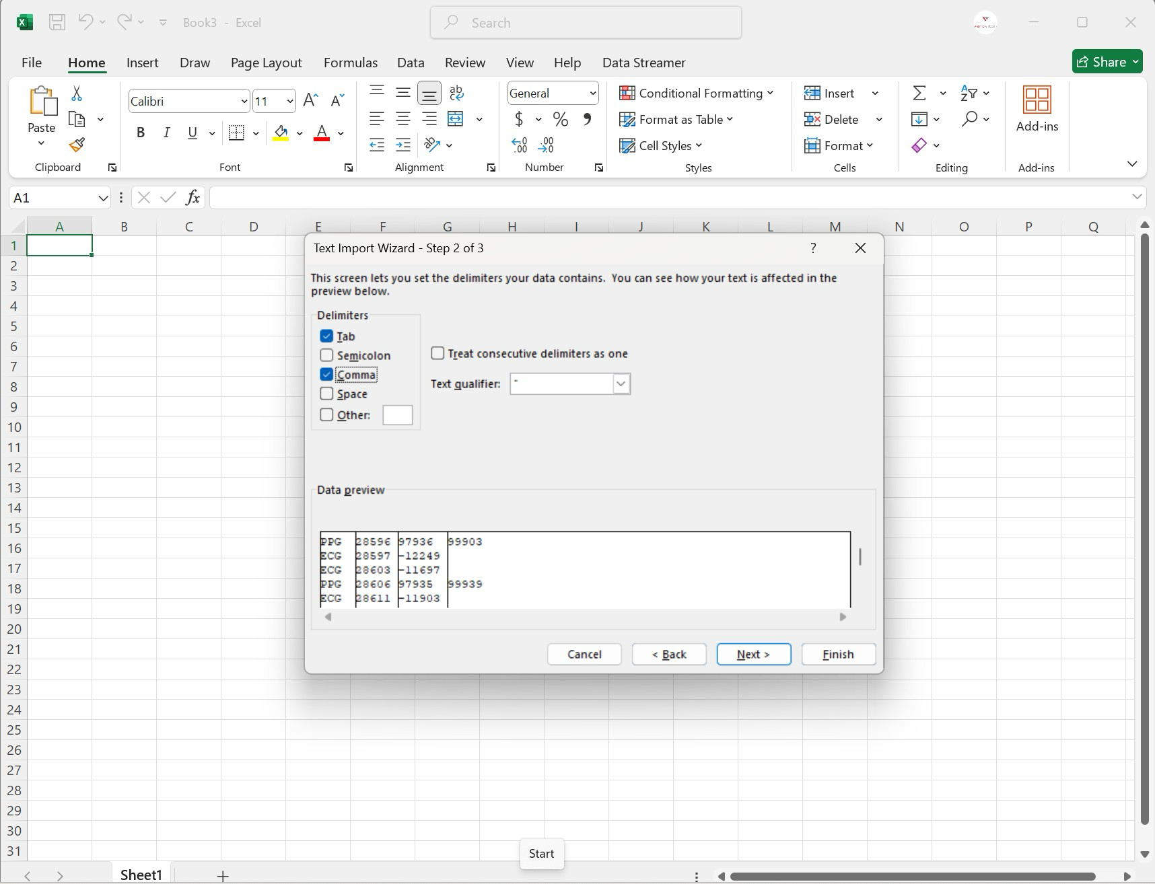
   3. If all settings look like the image above press “Next >”
5. Next you’ll be taken to the screen seen in the image below.
   1. 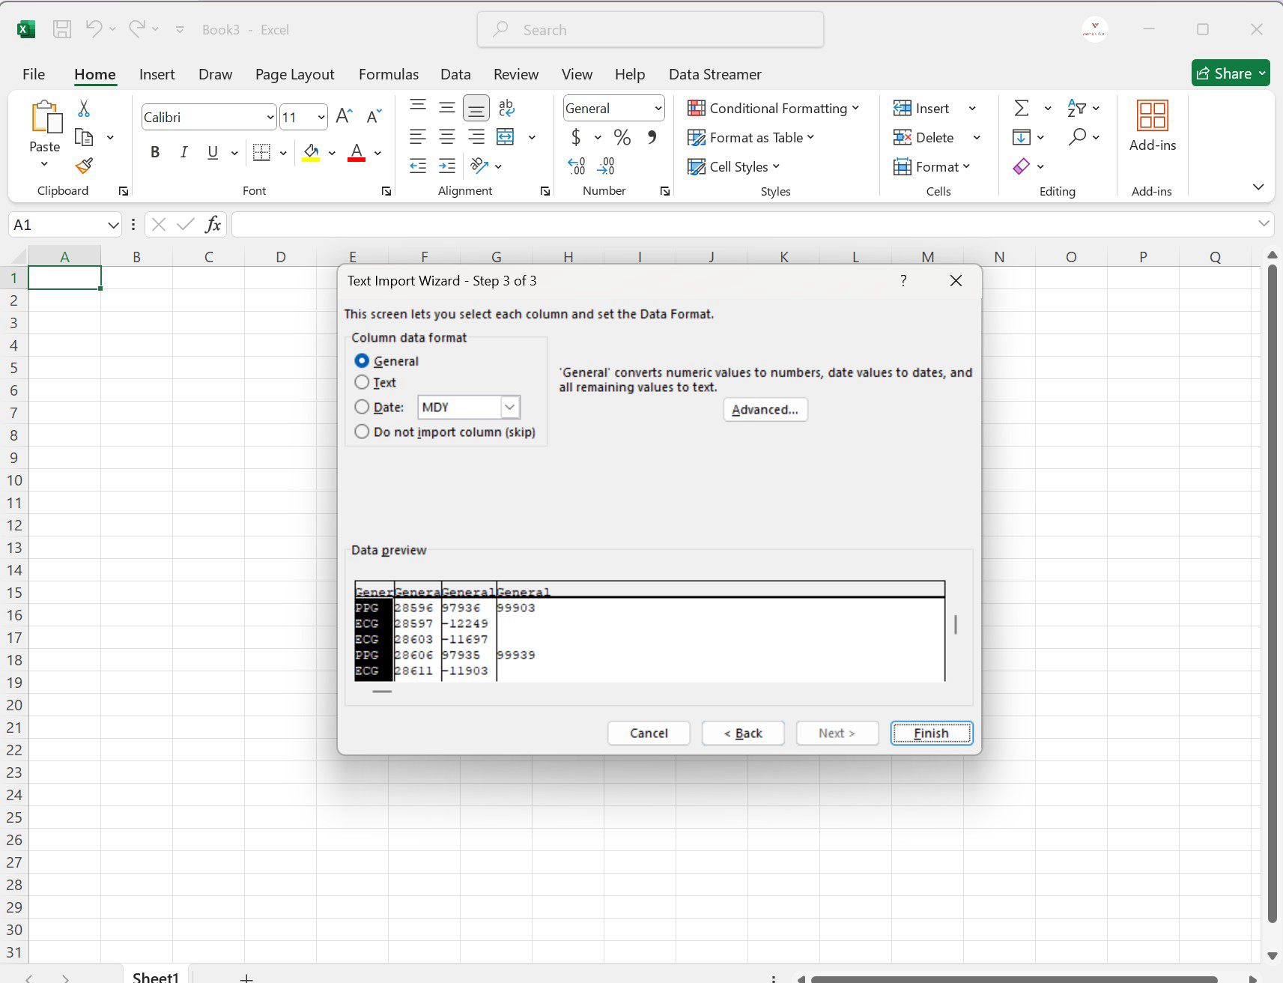
   2. If columns are separated correctly based on previous comma location press “Finish”
6. If the data file was opened correctly the excel file should look like the image below.
   1. 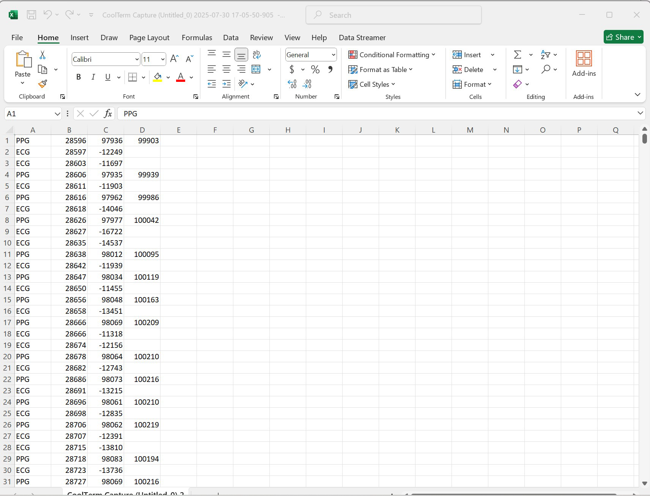
7. To save the file as a CSV go to “file” and “save as”.
8. Then when saving the location and file name make sure that the saved file type is “CSV (Macintosh)”, as seen in the image below.
   1. 